Assignment 2:
AI agent for Document reading is developed using the below nodes
1. On form submission – to upload the file from system
(Read/Write files from disk is not working in my system . So I chose to upload it )
2. Extract from file – to extract the data
3. Basic LLM chain to read and Answer questions
4. Convert to file – to get the content in a HTML file

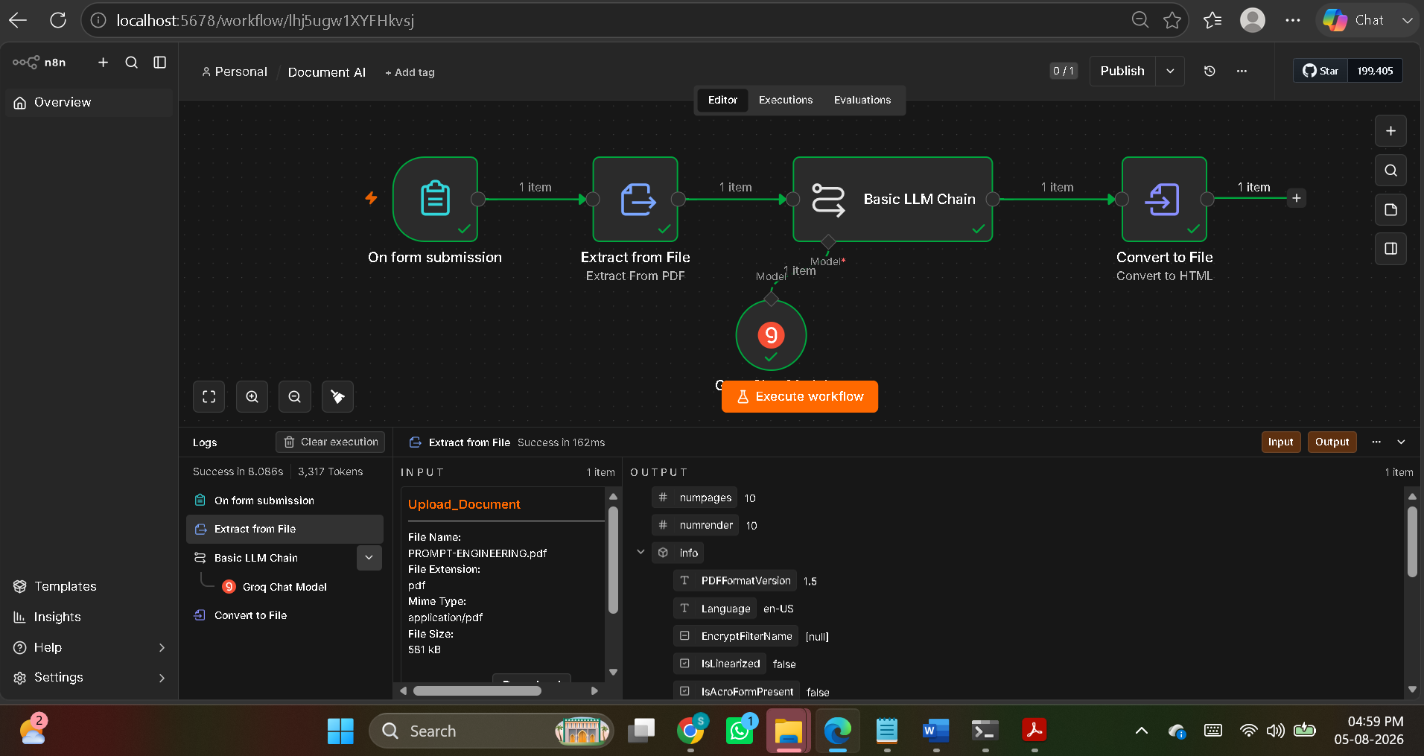

Prompt :
User message : Analyze the content of the document uploaded and give the answers for my questions as per the content.
{{ $json.text }} [STRICT] If i ask questions unrelated to the document content, AI should reply Out of scope instead of giving the answers. [IMPORTANT] Answers given should be derived only from the content of the document.No additional info should be added to the answers. Here are my questions 1. What are the Benefits of Prompt engineering ? 2. Give me the points of how does prompt engineering works ? 3. What is Contextual Prompt ? 4. What is Robotic Process Automation

AI output comparison with the document uploaded:
Questions irrelevant to the document is correctly answered as Out of scope.

AI Output:
Question and Answer irrelevant to the document uploaded is heighted in yellow
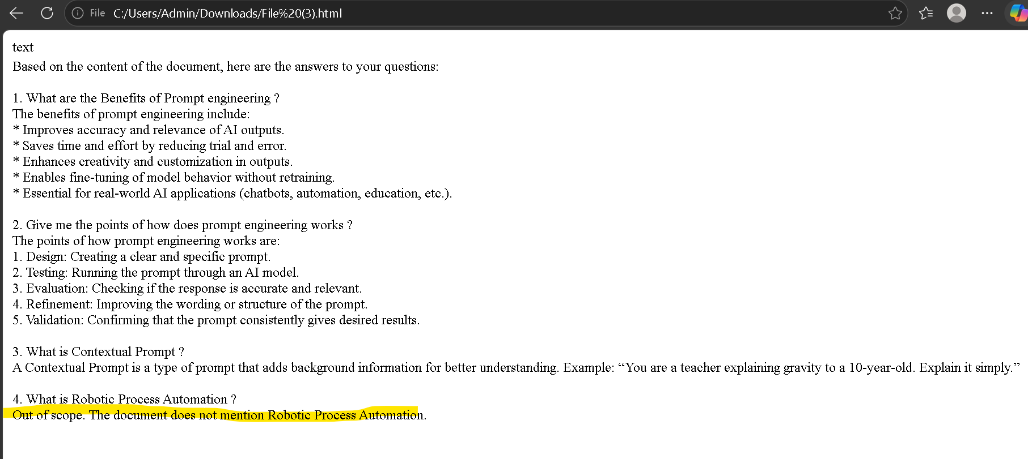

Doc content :

